https://svcnowprod.service-now.com/evg_sp/

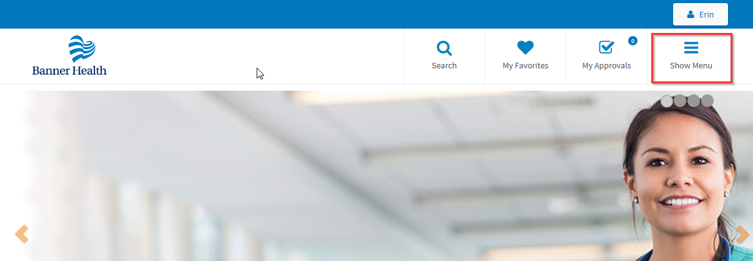

- Click on Show Menu
- Click on I need something to open the service catalog.
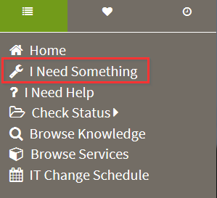
Search within the service catalog to narrow down your choices for Epic:
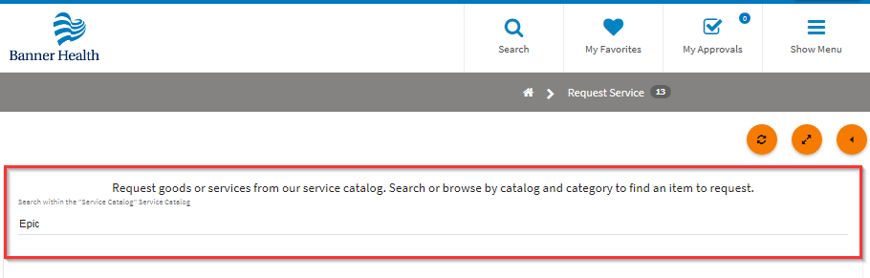
- Pick the most appropriate request or look for the Epic General request if you aren’t sure which one should be used:
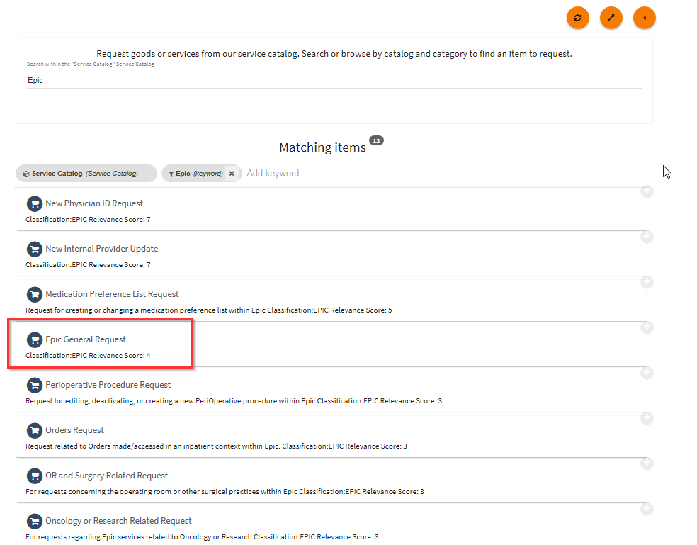
- Fill out required information.
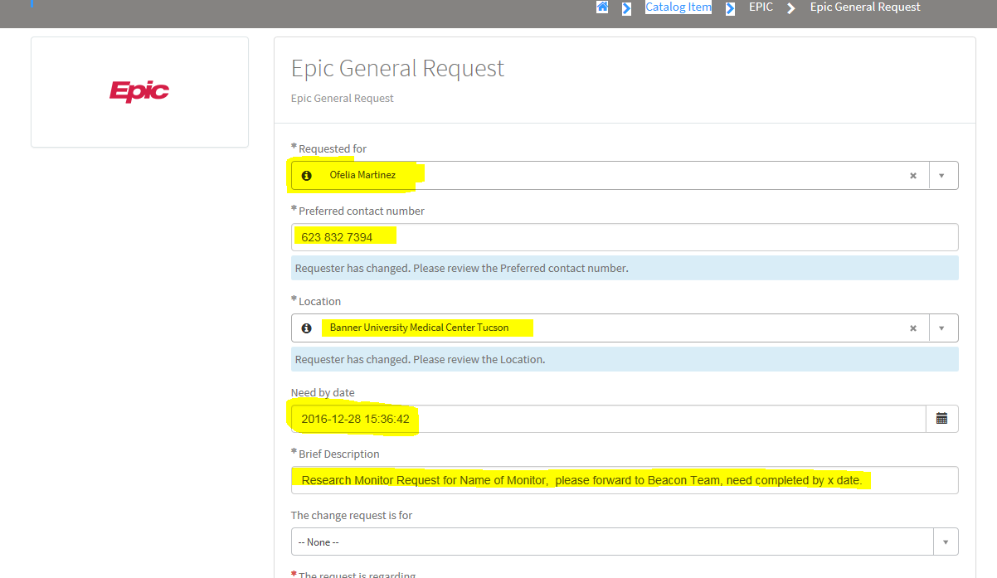
- Requested for – This is your name
- Preferred Contact number – This is your phone #
- Location -Type in Banner University Medical Center Tucson of Banner University Medical Center South
- Need by: Enter the date you need your request completed by.
- Brief Description – Type in Research Monitor request for X monitor, please forward to Beacon Team, need completed by X date.
Scroll all the way down leave all the other questions as is
- Add Attachment – Attach the list of patients that the monitor needs access to.
- Click on Submit
