Clinical Research Data Warehouse (CRDW)
Request Process
To support the use of Banner Clinical data for research purposes, a protocol entitled “Clinical Research Data Warehouse and Associated Honest Broker Processes” has been approved by the Banner IRB. The protocol details how Honest Broker staff, who are neutral intermediaries between the researcher and the EHR data, will take in requests for data, assess the feasibility of the requests, and ultimately fulfill the requests. Requests are initiated using the Research Intake Form: https://research.uahs.arizona.edu/clinical-trials/research-intake-form. A high-level overview of the process is given below: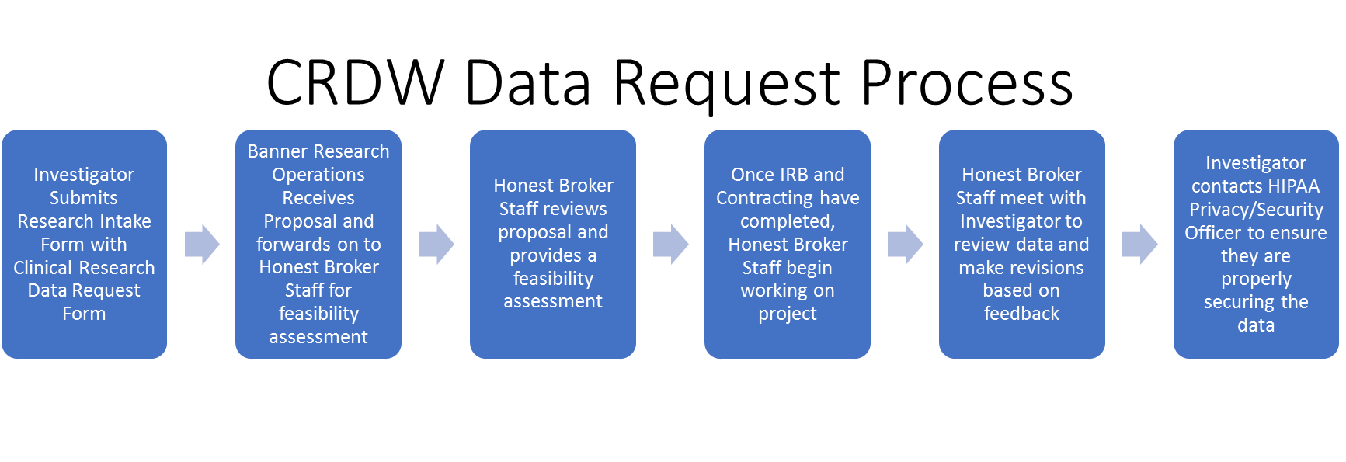
In our experience, having a well formed and complete data request to start with helps make the process move more smoothly. On the following page we have attempted to make a streamlined form that captures the necessary elements for a complete request. If you have any questions about the process or would like assistance on your data request, please feel free to contact us at: BHHonestBrokerDataRequest@bannerhealth.com.
Frequently Asked Questions (FAQ)
How long will a data request take? This is highly dependent on the scope of the request and the Honest Broker staff will provide an estimate as part of the feasibility review. Most frequently, the process generally takes 4 – 8 weeks until the data is extracted to the investigator’s satisfaction. Often there are other steps in the process such as contracting which can impact the overall time, so we ask that you submit your request as early as possible.
After receiving data, who do I contact about properly securing the data? Properly securing the data is of the upmost importance. Please contact the University of Arizona (UA) HIPAA Privacy Program at PrivacyOffice@email.arizona.edu for assistance in coordinating with your departmental IT staff to ensure that the data is properly secured. Additional information is available at the HIPAA Privacy Program’s website: https://rgw.arizona.edu/compliance/hipaa-privacy-program
What is involved in the contracting process? A Data Sharing Agreement (DSA) between Banner and UA will need to be in place. Banner Legal will send the initial DSA agreement to UAHS contracting at UAHSContracts@email.arizona.edu to initiate formal negotiations. Banner is currently working with UA to create a Master Agreement, at which time each project will be an addendum to the Master.
How can I determine the status of my request? For status updates, please email: BHHonestBrokerDataRequest@bannerhealth.com and include PI Name and Project Title. At some point in the future a dashboard may be put in place.
Clinical Research Data Warehouse (CRDW)
Request Form
Please complete all sections below and provide specific details when specifying inclusion/exclusion criteria and data points. Please also specify the facilities from which you are requesting data as well as the care settings (inpatient/outpatient/ED/ICU etc.) and the timeframes for the data. Incomplete forms may cause a delay in the project approval.
If diagnoses are used for inclusion/exclusion criteria, please specify the ICD codes; if lab tests are used, please specify the lab names and any ranges that may include/exclude; if medications are used, please specify the medications rather than a class such as “anti-coagulants” and include both generic and brand name.

Principal Investigator Name & Contact Information:
Click or tap here to enter text.
Project Title:
Click or tap here to enter text.
Inclusion Criteria:
Click or tap here to enter text.
Exclusion Criteria:
Click or tap here to enter text.
Data Points Requested (Be specific):
Click or tap here to enter text.
Timeframe to Collect Data (start date/finish date):
Click or tap here to enter text.
Facilities & Care Settings Utilized for Data Collection (i.e. inpatient/outpatient/ED/ICU, etc.):
Click or tap here to enter text.

